Introduction to Team Foundation Build 2017, Test Run Analysis and Machines

Lab version: 15.0.26228.0

Last updated: 3/3/2017

1. **TABLE OF CONTENTS**

Overview 1

Prerequisites 2

About the Fabrikam Fiber Scenario 2

Exercise 1: Build Agent Pools and Queues 2

Task 1: Touring the Build Hub in TFS Web Access 2

Task 2: Creating an Agent Pool 3

Task 3: Creating a Build Queue 5

Task 4: Installing and Configuring an Agent 9

Exercise 2: Build Definitions 11

Task 1: Creating a Basic Build Definition from Template 12

Task 2: Queuing and Executing a Build 21

Exercise 3: Continuous Integration and Deployment 23

Task 1: Cloning a Build Definition 23

Task 2: Adding a Deployment Step and Defining Machine Group 24

Task 3: Configuring Continuous Integration 26

Task 4: Triggering a Continuous Integration Build 28

# Overview

* 1. In this lab, you will learn how to use the new Team Foundation Build in order to build, test, and deploy your applications. This new scriptable build system is both web-based and cross-platform, and Microsoft recommends using it instead of the XAML build system whenever feasible. Although we won’t demonstrate all of the cross-platform possibilities in this lab, it is important to point out that you can also build for iOS, Android, Java (using Ant, Maven, or Gradle), and Linux.

## Prerequisites

* 1. In order to complete this lab you will need the Visual Studio 2017 virtual machine provided by Microsoft. For more information on acquiring and using this virtual machine, please see [this blog post](http://aka.ms/almvm).

## About the Fabrikam Fiber Scenario

* 1. This set of hands-on-labs uses a fictional company, Fabrikam Fiber, as a backdrop to the scenarios you are learning about. Fabrikam Fiber provides cable television and related services to the United States. They are growing rapidly and have embraced Windows Azure to scale their customer-facing web site directly to end-users to allow them to self-service tickets and track technicians. They also use an on-premises ASP.NET MVC application for their customer service representatives to administer customer orders.

In this set of hands-on labs, you will take part in a number of scenarios that involve the development and testing team at Fabrikam Fiber. The team, which consists of 8-10 people has decided to use Visual Studio application lifecycle management tools to manage their source code, run their builds, test their web sites, and plan and track the project.

# Exercise 1: Build Agent Pools and Queues

In this exercise, you will learn how to create and configure build agent pools and queues in order to support the new agents in Team Foundation Build 2017 (formerly referred to as Build vNext). This new scriptable build system is web-based and cross-platform, and is recommended for all new and existing builds going forward.

## Task 1: Touring the Build Hub in TFS Web Access

1. Log in as **Deniz Ercoskun (VSALM\Deniz)**. All user passwords are **P2ssw0rd**.
2. Let’s say that the Fabrikam Fiber team has been building their web applications using XAML build system, but that they are ready to move to the new scriptable TFS build system that was made available in 2015. Since they have been relying on a standard build template, the transition to the new build system should be relatively straightforward.
3. Let’s get started by touring the **Build** hub in the web portal. Launch **Internet Explorer** from the taskbar and click **TFS FF Portal** from the favorites bar at the top.

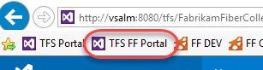

1. Select the **Build & Release** tab.



1. Select the **XAML** tab to view the project’s XAML build definitions. Here you can see the existing **Nightly Fabrikam (Dev)** XAML build definition that is currently used by the team to validate the development branch.

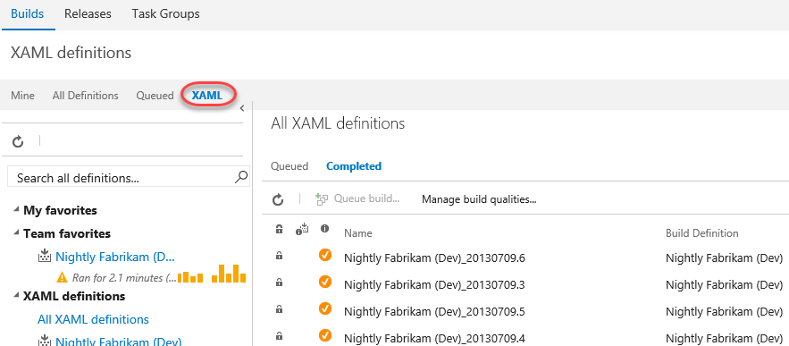

1. We’ll return to this view shortly once we are ready to translate the existing XAML build to the new system, but first we need to configure the infrastructure necessary for the new build system.

## Task 2: Creating an Agent Pool

1. The first thing that we need to do is to setup an agent pool for the project. This pool can contain both Windows and cross-platform agents.
2. Hover over the **gear** icon in the navigation bar and select **Agent Queues**.

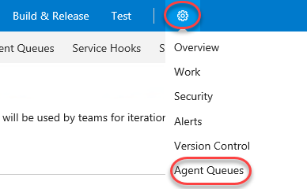

1. There is already an agent queue named **“default”** with a single agent as shown here.

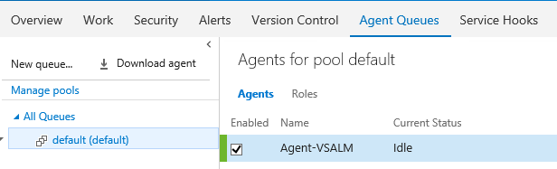

1. Select the **Roles** tab to view queue security. You can precisely define who can access these agents and how.

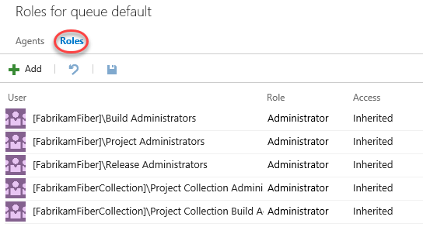

1. Click **Manage pools** to view all available agent pools. This will open a new tab.

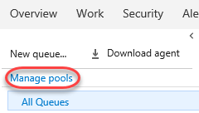

1. Select the **default** pool’s dropdown and select **Delete** to delete the pool and its agents. Confirm the delete when asked. You’ll go through the process of adding these back later on.

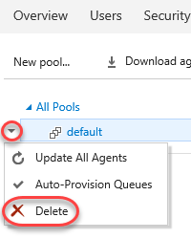

1. Close the pool management tab. This should leave you with a single queue management tab.

## Task 3: Creating a Build Queue

1. Before we continue with the installation of an agent, let’s also ensure that we set up our team project collection with a build **queue** that points to the default agent pool. Since queues are scoped to your team project collection, you can share them across build definitions and team projects.
2. This diagram from the MSDN documentation helps to illustrate the relationship between pools, queues, team project collections, and build definitions. Note that you can also install multiple agents on a single machine.

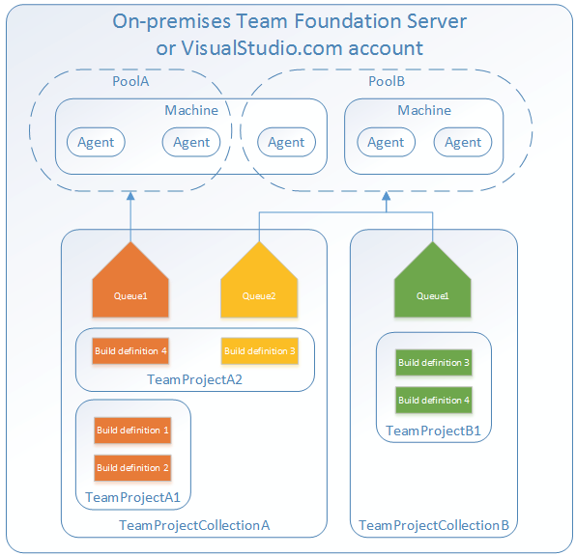

1. Select the **Agent Queues** tab and click **Download agent**.

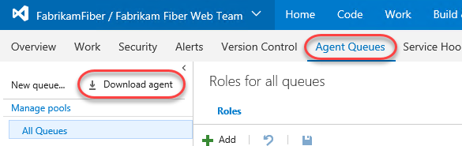

1. Click **Download** and save the target to disk in a convenient place. Then close the agent download dialog. This download may take a few minutes, so you can continue to the next step.

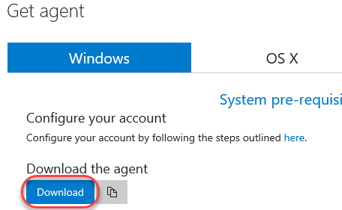

1. Click **New queue** to create a new queue.

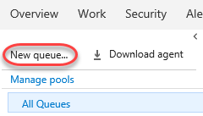

1. Enter a **Pool name** of “**default**” and click **OK**.

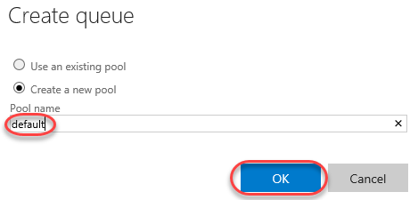

1. It is also possible to configure collection-level build settings. From the gear dropdown, select **Collection settings**.

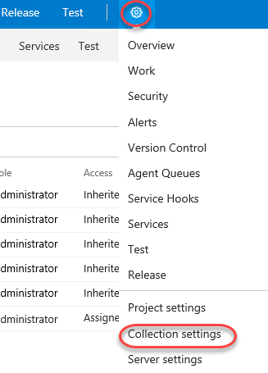

1. Select the **Build and Release** tab. From here, you can specify the default and maximum settings for how long the system retains completed builds. The default retention policy is set at 10 days, with the maximum at 30 days. This means that regardless of what is set on the individual build definition all builds that have not been marked to "Retain indefinitely" will be deleted 30 days after they complete.

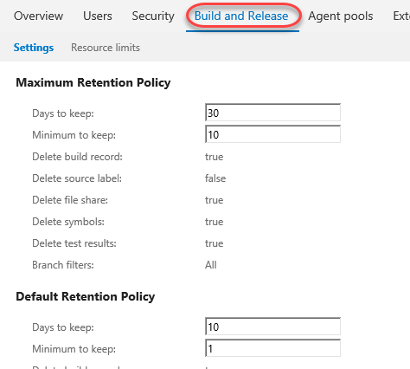

## Task 4: Installing and Configuring an Agent

1. Wait for the agent download to finish if it has not already. Unzip it to **c:\agent** when complete.

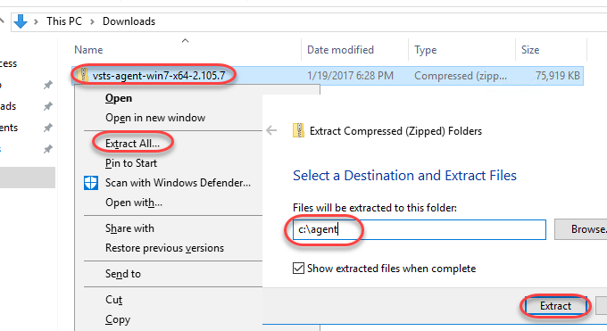

1. Launch an instance of **Command Prompt** as **Administrator** from the taskbar.
2. Change to the unzipped agent directory.

cd c:\agent

1. Execute the agent configuration script.
   1. config.cmd
2. Enter the server URL “<http://vsalm:8080/tfs>”.
3. Press **Enter** for **Integrated** authentication.
4. Press **Enter** to use the default agent pool of “default”.
5. Press **Enter** to use the default agent name of “VSALM”.
6. Press **Enter** to use the default path proposed for the agent work folder “c:\agent\_work”.
7. When asked if you want to install as a Windows Service, type **“Y”** and then press **Enter**. Note that you could also configure the agent to run in interactive mode, which you may want to do if you were planning to execute coded UI tests.
8. Press **Enter** to run as network service, rather than providing a specific user account.
9. After a few moments, the script should complete with the successful installation and configuration of the new agent.

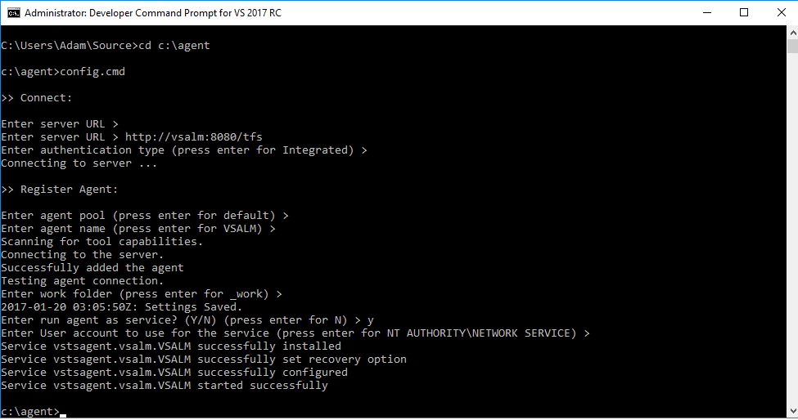

1. **Note:** You weren’t prompted for credentials in this case, but under normal circumstances when installing on a remote machine you would be asked to sign in as an agent pool administrator. These credentials are only used once during the configuration process.
2. Return to **Internet Explorer** and refresh the window to see the new **default** queue. Click **Manage pools**.

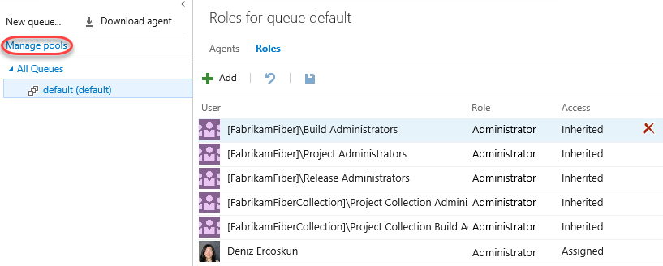

1. Select the **Capabilities** tab to take note of the System Capabilities list shown for the agent. System capabilities are name/value pairs that you can use to ensure that your build definition is only run by build agents that meet specified criteria. Environment variables automatically appear in the list. Some additional capabilities (such as .NET Frameworks) are also added automatically. You can also add your own capabilities to the list based on additional requirements for your builds. Later, when a build is queued, the system sends the job only to agents that have the capabilities demanded by the build definition.

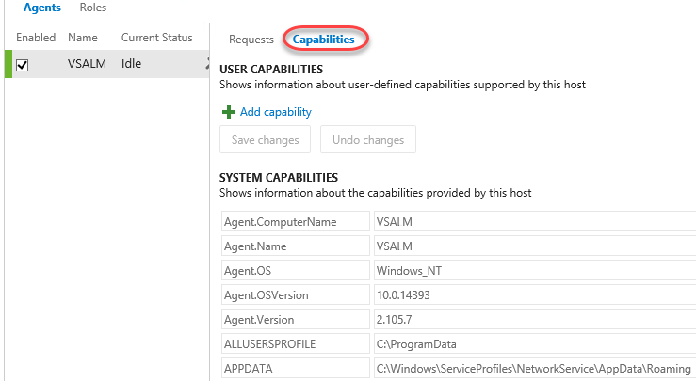

# Exercise 2: Build Definitions

* 1. In this exercise, you will learn how to create a basic build definition from one of the provided templates and then queue the build for execution.

## Task 1: Creating a Basic Build Definition from Template

1. Now it is time to create a new build definition for the Fabrikam Fiber team. Navigate to the web team’s section of the portal using the project dropdown.

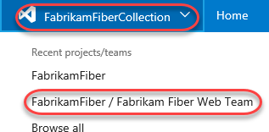

1. Select the **Build & Release** tab and click **New definition** to create a new build definition.

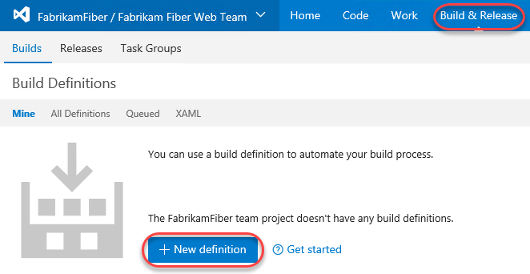

1. The **Definition Templates** dialog lists a few different build templates that you can start with in order to build and test using Visual Studio, Xamarin, and Xcode. Alternatively, you can also simply start with an empty definition and add in the tasks that you need.

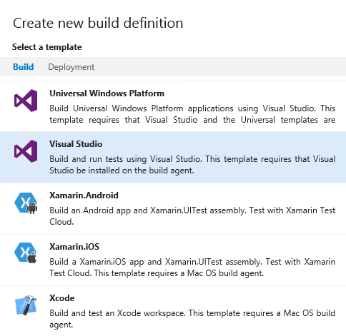

1. Click the **Deployment** tab and note that templates are also provided that help accelerate deployment to Azure.

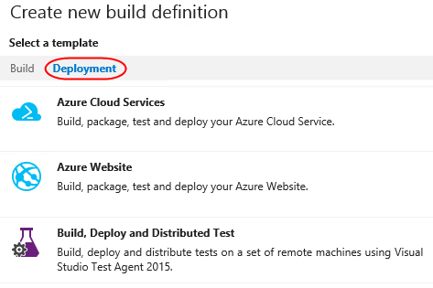

1. Return to the **Build** tab, select the **Visual Studio** template, and then click **Next**.

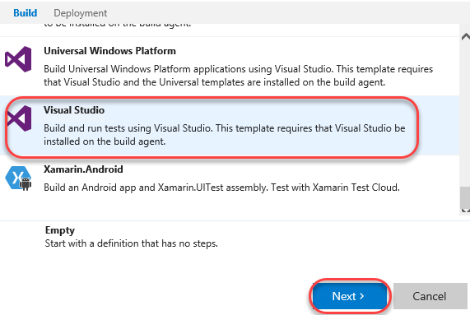

1. Select **FabrikamFiber Team project** as the **Repository source** and click **Create** to create the build definition.

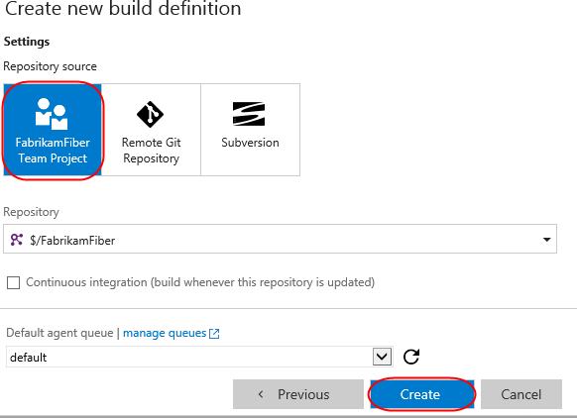

1. The new build definition is initially set up with build steps that initiate a NuGet restore, a Visual Studio build, a test pass, publication of symbols for archival, a copy of the files to a staging location, and finally a publish of the build output to a drop location. These steps are all defined on the **Build** tab.
   1. **Note:** The build engine and tasks are both extensible, and are designed to be cross platform. In the event that you need a task that isn’t offered out of the box, you can create your own using the open source activities found on GitHub [here](https://github.com/Microsoft/vso-agent-tasks). This is also a good location to dig into if you would like to learn more about how the existing tasks work.

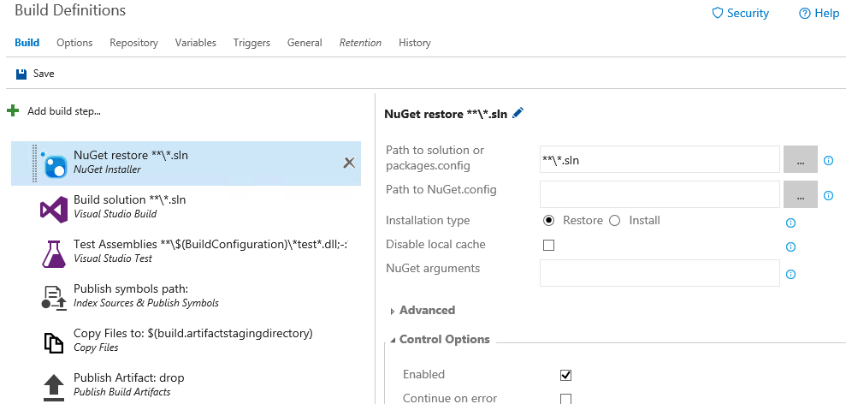

1. Before we take a closer look at the configuration of the individual build steps, let’s take a look at a few of the key configuration options for the build definition itself, which are shown as tabs across the top. Click the **Options** tab.

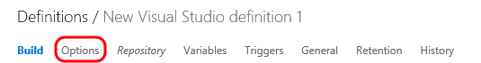

1. The **Options** tab provides the MultiConfiguration option than can be enabled to build multiple configurations for multiple platforms. Select the **MultiConfiguration** option to enable it.
2. For **Multipliers**, enter **“BuildPlatform, BuildConfiguration”** in order to take into account these variables during the build.

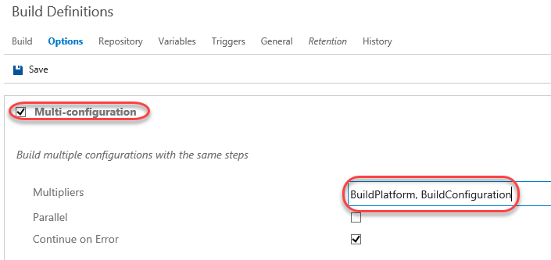

1. Enabling the **Parallel** option would allow you to distribute the jobs (one from each combination of values from Multipliers) to multiple agents in parallel (if available). However, since we only have one agent installed, we won’t be able to parallelize the build here.
2. Select the **Variables** tab. This list shows variables that will be available to all build steps (tasks). There are a number of predefined variables that can be used by tasks during the build, all listed [here](http://go.microsoft.com/fwlink/?LinkId=550988), as well as any additional variables that can be added in this view. By default, both **BuildConfiguration** and **BuildPlatform** are already defined here (we just referenced these in our configuration of Multipliers prior).

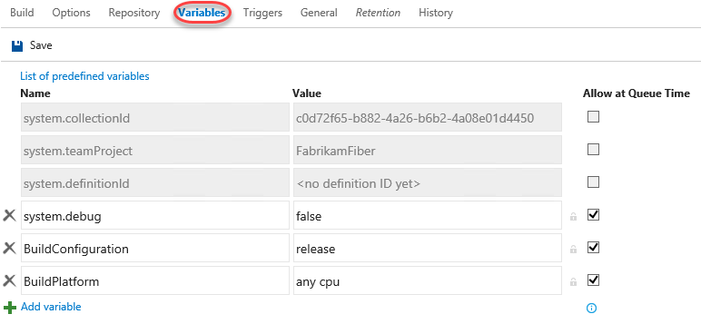

1. Although we will not do so for the purposes of this demo, you could modify BuildConfiguration to be “debug, release” in order to build both versions.
   1. **Note:** Using variables is a great way to specify secrets as well. If you were to add in a variable to contain a password, for example, you could click the Secret button just to the right of the Value column (lock icon) to prevent it from being displayed here.
2. Click the **Repository** tab. This is where you specify the source repository for build. In this case, **Team Foundation Version Control** is already selected for Repository Type and **FabrikamFiber** is selected as Repository Name. Of course, it is certainly possible to build from any Git repo as well. Set **Clean** to **true** so that the files are cleaned each pass.

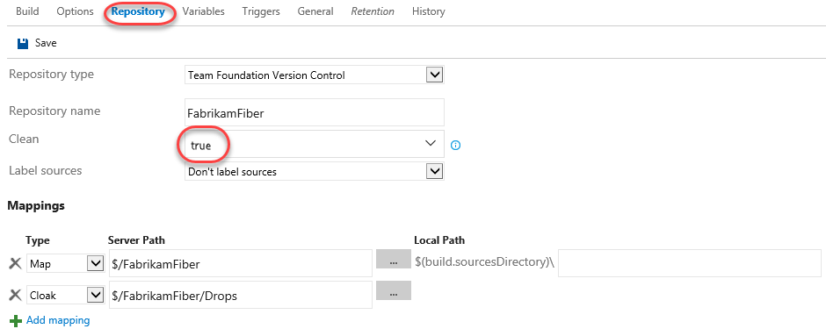

1. You can also configure mappings in order to pull down just the subset of code necessary in order to build. Click the **ellipses** button to the right of the first default mapping currently configured as “$/FabrikamFiber”.

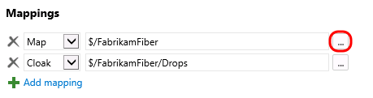

1. In this case, we would just like to build the Dev branch of the code, so select the **Dev** branch node and then click **OK**.

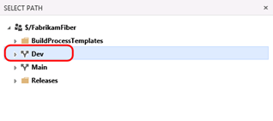

1. Modify the second default mapping manually (of type Cloak) to be **“$/FabrikamFiber/Dev/Drops**”.

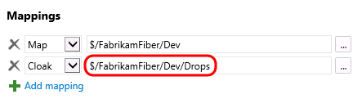

1. Select the **Triggers** tab. Although we will not use them in this definition, this is where you can configure continuous integration or schedule the build.

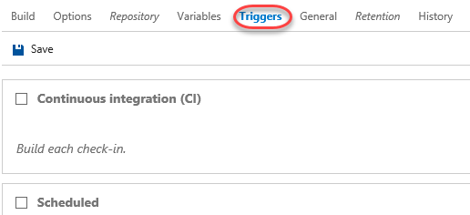

1. Select the **General** tab. This is where you configure the default queue to use, build number format, build timeout, and other general settings. This is also where you can specify demands for specific agent capabilities. By default, we have demands already in place to ensure that MSBuild, Visual Studio, and VSTest capabilities are defined for the agent.

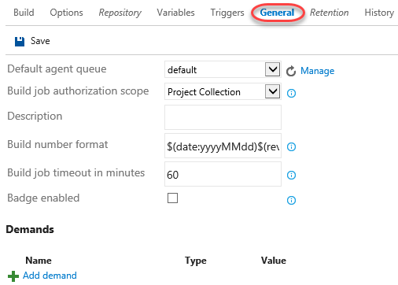

1. Select the **Build** tab. The first build step restores any NuGet packages that might be out of date. There are a variety of options for configuring this, such as the ability to disable the local cache. Leave these options as defaults.

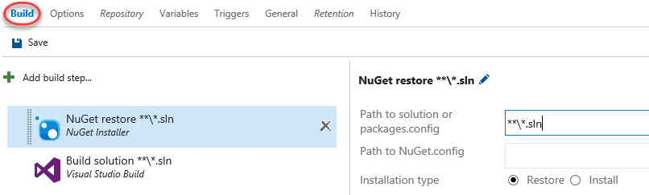

1. The second build step defined by this template is for **Build solution**. By default, it is configured to build all solution files in all subfolders, use the platform specified by the BuildPlatform variable, and use the configuration specified by the BuildConfiguration variable. Ensure **Visual Studio “15” (preview)** is selected as the **Visual Studio Version** (this will build as Visual Studio 2017).

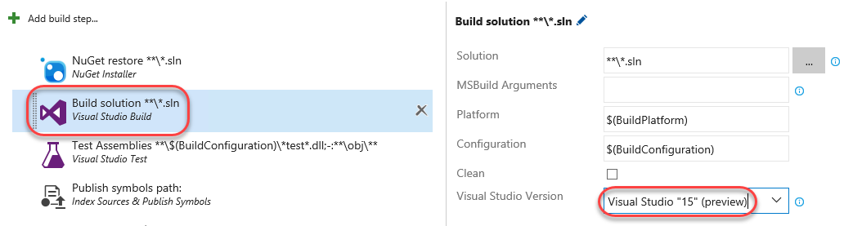

1. The third build step is **Test Assemblies**. We will mostly use default options here to test assemblies with “*Fabrikam*test” in the name. Update the **Test Assembly** field to **“**\$(BuildConfiguration)\*Fabrikam*test*.dll;-:**\obj\**”**. Note that this is really just inserting “*Fabrikam” before “*test”.

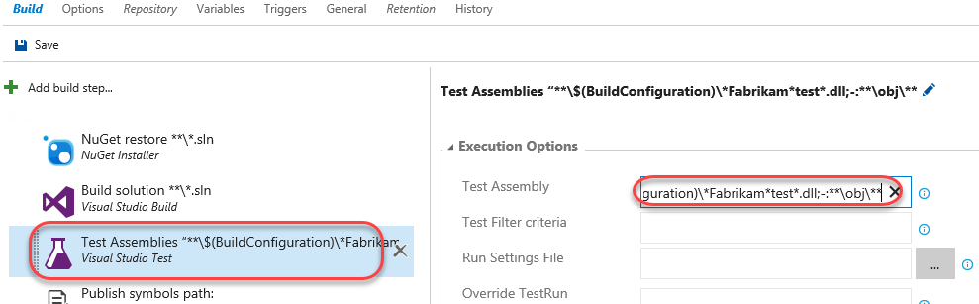

1. Expand the **Advanced Execution Options** section and note the additional options, such as the ability to specify a specific version of VSTest or paths to custom test adapters.

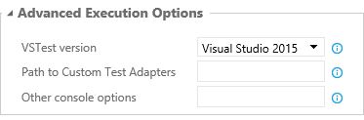

1. Before we move on to the next build step, select the **Continue on Error** option (from the Control Options section) so that subsequent steps will be executed even if some tests fail. The reason that we are doing this is because this virtual machine has some tests that are setup to fail for demonstration purposes.

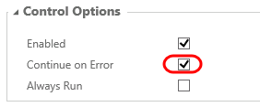

1. Select the next build step named **Publish symbols path**. This is where you can specify a path to a symbol store share, although we will not do so at this time.

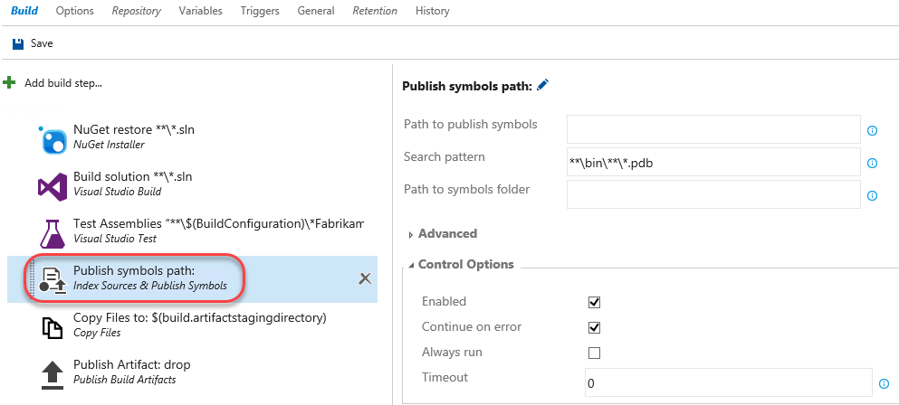

1. The fifth build step is **Copy Files** and places a copy of the build into a staging directory.

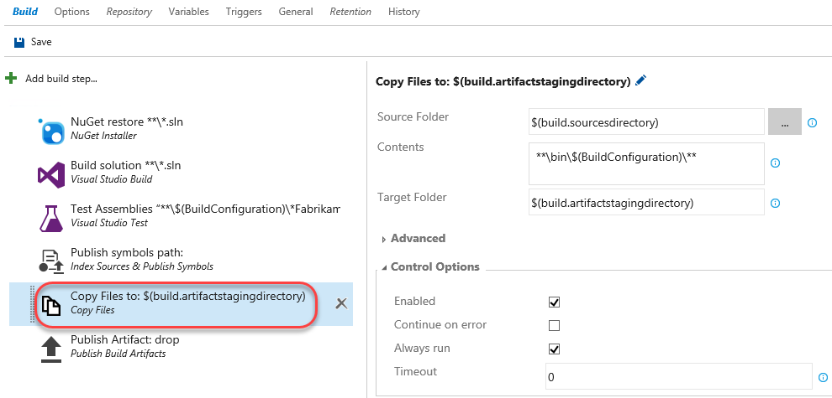

1. Select the final build step named **Publish Artifact**. This step will take the build output from the bin folder, zip it up into a build artifact named “drop”, and then upload it to the TFS server.

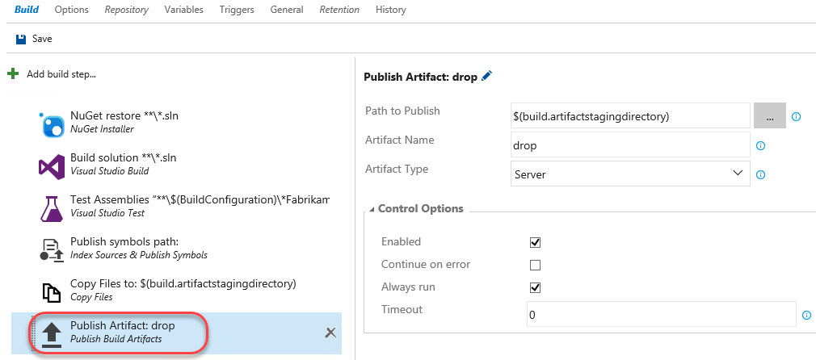

1. Click **Save**. Name the new build definition “**Fabrikam Development Build**” and click **OK**.

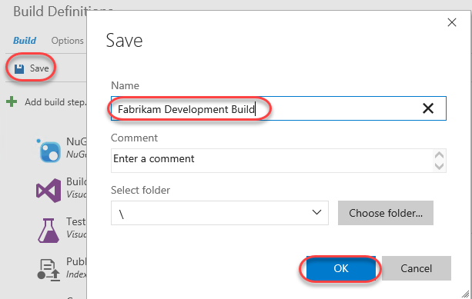

## Task 2: Queuing and Executing a Build

1. Click **Queue new build**.

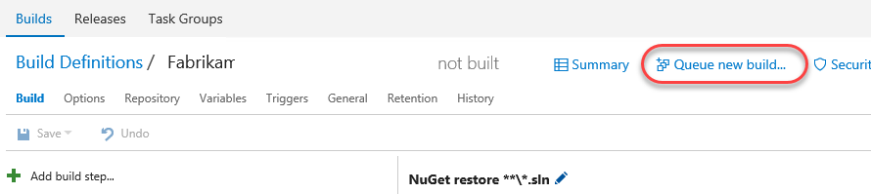

1. Note that the Queue Build dialog allows you to configure the queue, optionally select a shelveset, variable values, and demands. Use the defaults presented by clicking OK.

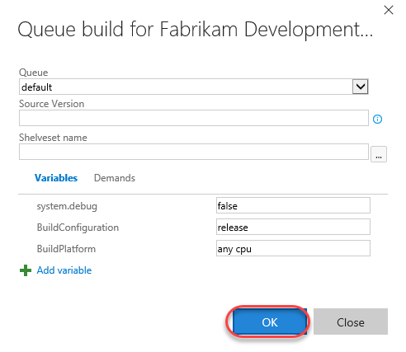

1. Note that once the build starts, you can monitor the real-time build status in the live console view. As the Test step proceeds, you will see some red error text as there are some tests in this project that are designed to fail for demonstration purposes. At the end of the build you should see the message in orange displaying “Build Partially succeeded”. Note that you may need to refresh the browser if the build hasn’t started yet.

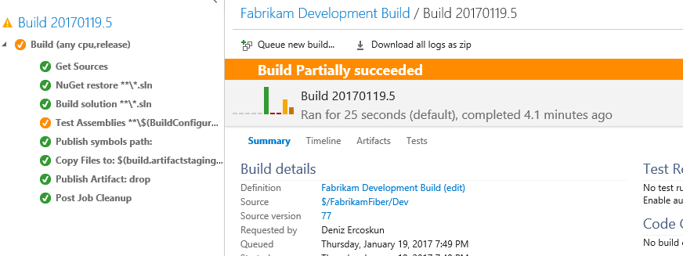

# Exercise 3: Continuous Integration and Deployment

* 1. In this exercise, you will learn how to modify a build to support continuous integration. In addition, you will also learn about some of the deployment options available.

## Task 1: Cloning a Build Definition

1. Now let’s create a similar build definition, but this time include a step to deploy the Fabrikam Fiber website. Imagine that this build definition will be part of a continuous integration scenario.
2. Return to the main Build view by selecting the **Builds** tab.

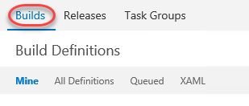

1. Select the **Ellipses** drop-down just to the right of the **Fabrikam Development Build** definition to load the associated context menu. Note the options that allow us to create a new build definition using the current one as a starting point: **Clone** and **Save as a Template**. If we wanted to share this build definition as a template with the rest of our team, we could do so here and it would show up as a Custom template when creating a new definition. In this case, click **Clone** to create a copy of the current definition.

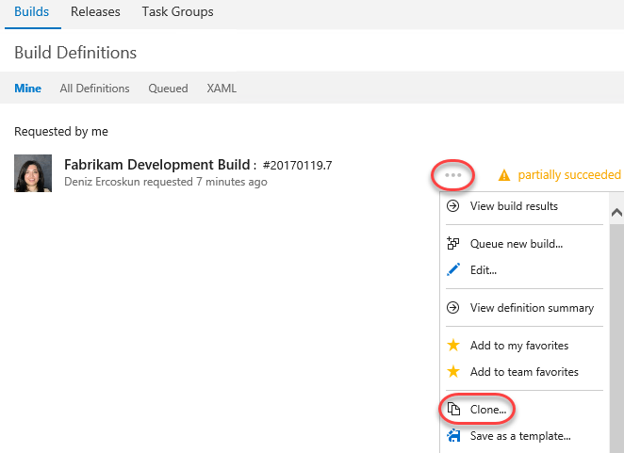

## Task 2: Adding a Deployment Step and Defining Machine Group

1. Click Add build step.

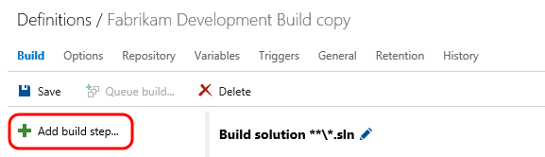

1. Select the Deploy tab and check out the available options that range from Azure Web Site deployment to PowerShell execution and file copy. For simplicity, let’s deploy to the local machine using the Windows Machine File Copy step, so click Add. Then Close the dialog.

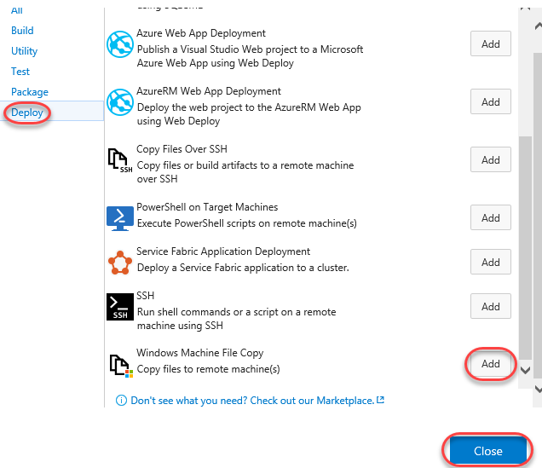

1. Select the new Windows Machine File Copy step.

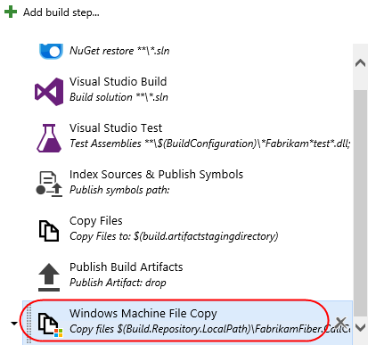

1. Set the **Source** property to be the following:

$(Build.Repository.LocalPath)\FabrikamFiber.CallCenter\FabrikamFiber.Web

1. Set **Machines** to **“vsalm”**.
2. For the purposes of this demo, we will continue to work within this virtual machine, so enter credentials for **vsalm\administrator** (password is **P2ssw0rd**).
3. Now we need to specify the target copy location on the destination machine. Enter **“c:\inetpub\FabrikamFiber.Web”** to the right of the **Destination Folder** field.
4. Select the **Clean Target** option under **Advanced Options** so that the copy location will be cleaned before each deployment.

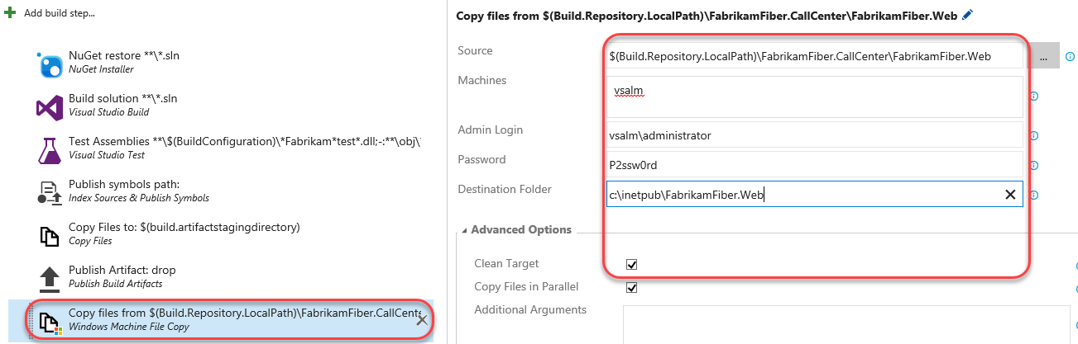

## Task 3: Configuring Continuous Integration

1. Now let’s get the continuous integration functionality hooked up. Select the **Triggers** tab and check the **Continuous integration** option.

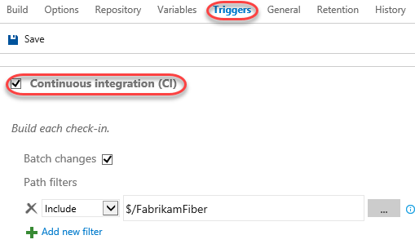

1. You can add filters to include or exclude certain source paths. Click the **ellipses** button to the right of the default include path that is currently set to “$/FabrikamFiber”.

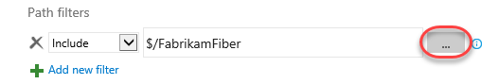

1. In the **Select Path** window, expand and select **$/FabrikamFiber/Dev/FabrikamFiber.CallCenter/FabrikamFiber.Web**. Click **OK**.

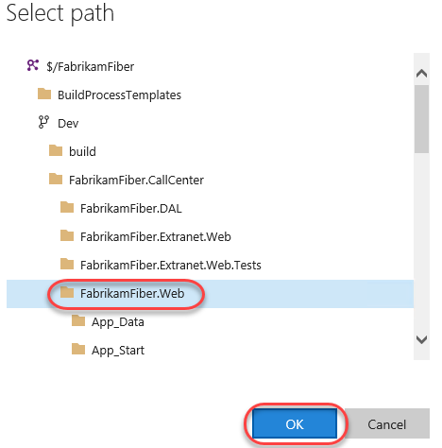

1. There is also an option here to trigger the build on a set schedule. For example, we could set this build up to run every evening if desired.
2. Click **Save**. Name the new build “**Fabrikam Development CI Build**” and then click **OK**.

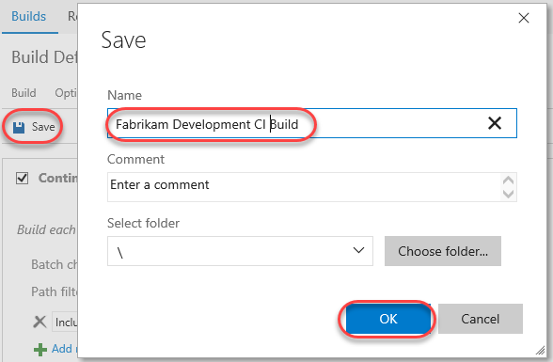

## Task 4: Triggering a Continuous Integration Build

1. In a new browser window or tab, navigate to the **Code** tab.

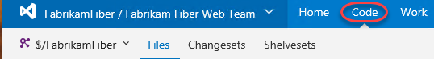

1. Open **$/FabrikamFiber/Dev/FabrikamFiber.CallCenter/FabrikamFiber.Web/readme.txt** by entering the path into the **Path** field and pressing **Enter**. Alternatively, you can use the tree navigation on the left. Click **Edit** to enter edit mode.

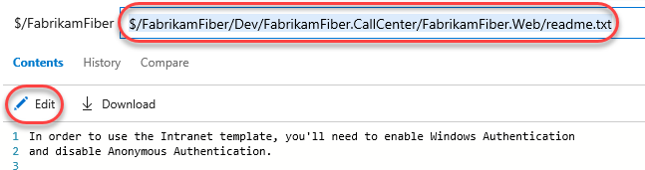

1. Make any change to the file and click **Save**.

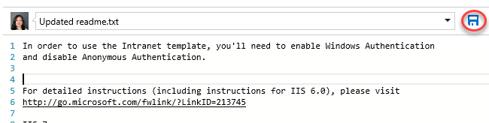

1. Select the **Build & Release** tab and open the **Fabrikam Development CI Build** by clicking it.

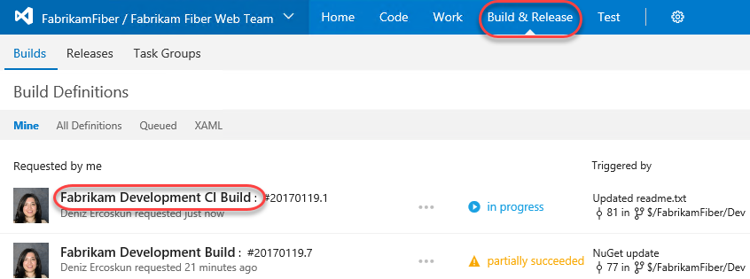

1. Here you can review the build results.

